GROUP B

WEEK 5
UtiliCare Help-Desk Triage Agent
Agent Architecture Diagram
This diagram shows how the UtiliCare Help-Desk Triage Agent works as a loop: it senses a customer's message, plans a response with Gemini, acts through two guarded tools, observes the results, and then stops or re-plans. The agent is advisory only; any consequential action stays with a human help-desk agent.
The loop stages shown on the next page:
- Sense: validate the request and retrieve grounded context from the local knowledge base.
- Plan / Decide: send the message, context and tool schema to Gemini and validate its JSON reply.
- Act / Tool: run get_outage_status (read-only) or draft_ticket (draft only, pending approval).
- Observe: collect structured tool results and reject malformed output.
- Stop / Re-plan: return the triage result, or retry / ask a clarifying question.
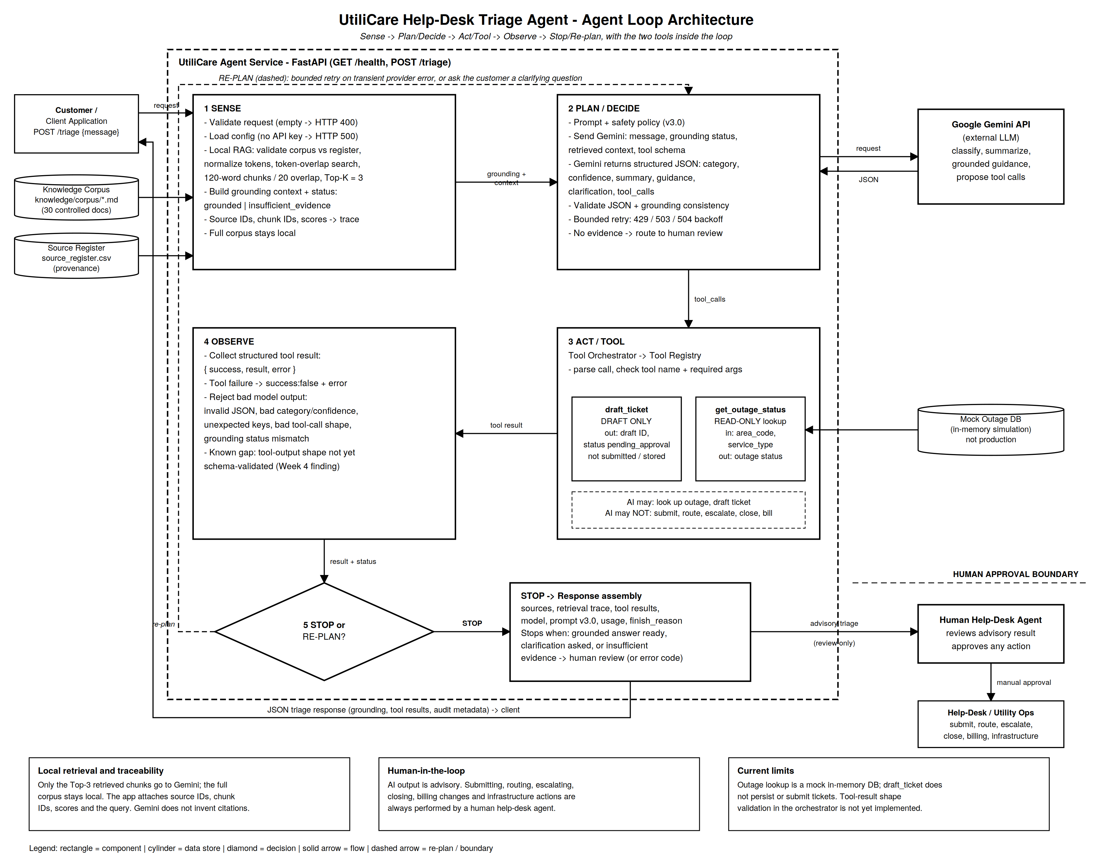

Key Parts of the Architecture
The parts below are the ones that matter most for understanding how the agent behaves, stays grounded, and stays safe. Each corresponds to a block in the diagram.

1. Sense: request handling and local retrieval
The FastAPI service exposes GET /health and POST /triage. It rejects empty messages, then runs a local, deterministic retriever over a controlled knowledge base of 30 markdown documents. Documents are split into 120-word chunks with 20 words of overlap, matched to the customer's message by token overlap (with simple normalization such as billed/billing to bill), and the top three chunks are kept. The result is a grounding status: grounded, or insufficient_evidence. This is a lexical retriever, not embeddings or a vector database, which makes it predictable and easy to audit.

2. Plan / Decide: the Gemini call and its guardrails
The agent sends Gemini the system prompt (version 3.0), the tool schema, the grounding status, only the retrieved chunks, and the customer's message. Gemini must answer in structured JSON: category, confidence, summary, grounded guidance, grounding status, whether clarification is needed, an optional clarifying question, and any proposed tool calls. When there is no evidence, the model is told to send the case to human review rather than answer from its own memory. Transient provider failures are retried with bounded exponential backoff.

3. Act / Tool: the orchestrator and the two tools
Model-proposed tool calls never run directly. The tool orchestrator parses each call, checks the tool name against the registry, and checks required arguments before executing anything. Only two tools exist:
- get_outage_status: a read-only lookup that needs area_code and service_type. It currently reads a mock in-memory outage database.
- draft_ticket: creates a ticket draft with a generated ID and always returns the status pending_approval. It does not submit, route or store a ticket.

4. Observe: structured results and output validation
Every tool outcome is returned in one shape: success, result and error. A failing tool becomes success: false with an error message instead of crashing the request. On the model side, the application rejects invalid JSON, missing or unexpected keys, unsupported categories or confidence values, a grounding status that disagrees with the retriever, inconsistent clarification fields, and malformed tool calls.

5. Stop / Re-plan: how the loop ends
The loop stops when a grounded answer is ready, when a clarifying question is needed, or when evidence is insufficient and the case goes to a human. Re-plan in the current design means a bounded retry after a transient Gemini error, or asking the customer a clarifying question. In the code described so far, tool results are returned in the response rather than fed back to Gemini for another reasoning pass, so a full tool-then-re-reason loop would be a future extension.

6. Human approval boundary
This is the most important safety property. The AI may look up simulated outage information and prepare a ticket draft. It may not submit, route, escalate or close tickets, change billing, control infrastructure, or make financial commitments. The triage result goes to a human help-desk agent for review, and only that person performs consequential actions. There is no direct path from the AI result to an automatic action.

